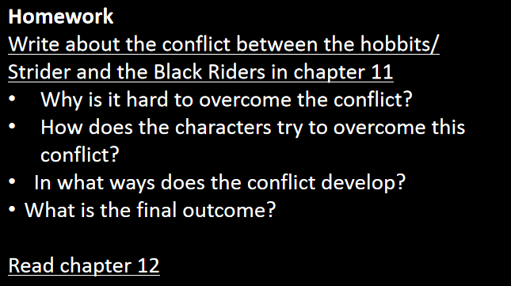  
answers:

1 there are too many Black Riders and they are too strong.

2 they used they’re swords to fight with the Black Riders.

3 Frodo puts on the ring and was stabbed by the Black Riders by a sword.

4 they yelled for help and then Strider came and fight with the Black Riders and rescued them.